**23CCE284 – DATABASE MANAGEMENT SYSTEM LABORATORY**

**A Report on**

**STUDENT DATA MANAGEMENT SYTEM**

DHARANESH P – CB.EN.U4CCE23009

JAYANTH CR – CB.EN.U4CCE23018

**VISHAL KB – CB.EN.U4CCE23019**



**DEPARTMENT OF ELECTRONICS AND COMMUNICATION ENGINEERING**

AMRITA SCHOOL OF ENGINEERING,

AMRITA VISHWA VIDYAPEETHAM,

COIMBATORE , INDIA - 641112

**TABLE OF CONTENTS**

|  |  |  |
| --- | --- | --- |
| **SNO** | **TITLE** | **PAGE NO** |
| 1 | Abstract | 3 |
| 2 | Objectives | 3 |
| 3 | Introduction | 4 |
| 4 | Schema diagram | 5 |
| 5 | ER diagram | 9 |
| 6 | Methodology | 16 |
| 7 | UI Interface | 18 |
| 8 | Functionalities | 26 |
| 9 | Conclusion | 27 |

**ABSTRACT**

The Student Data Management System is a database-driven project designed to streamline and efficiently manage student-related data within an academic institution. Implemented using MySQL, the system organizes information about students, faculty, courses, hostels, payments, grades, and administrative staff, ensuring data integrity and security through relational constraints. The project enables role-based access for students, instructors, administrators, and hostel wardens, facilitating structured management of academic records, hostel allocations, fee payments, and performance tracking. With well-defined one-to-one, one-to-many, and many-to-many relationships, the database ensures seamless information retrieval and updates. This system serves as a scalable solution for educational institutions, enhancing efficiency in student data handling while paving the way for future improvements like web-based interfaces and automated notifications.

**OBJECTIVES**

1. **Efficient Student Data Management** – To systematically store, retrieve, and manage student records, including personal details, academic performance, and hostel allocations.
2. **Role-Based Access Control** – To implement a secure login system with different access levels for students, instructors, administrators, and hostel wardens.
3. **Seamless Course and Faculty Management** – To maintain records of courses, instructors, and department heads, ensuring a structured academic workflow.
4. **Hostel and Accommodation Management** – To track hostel allocations, available capacity, and warden responsibilities for both boys' and girls' hostels.
5. **Fee and Payment Tracking** – To manage tuition, hostel, mess, and bus fees, enabling easy tracking of payments and due dates.
6. **Grade and Performance Monitoring** – To store and retrieve student grades, ensuring efficient academic evaluation and report generation.
7. **Automated Pass Request System** – To facilitate online requests for city/home passes and track their approval status.
8. **Data Integrity and Security** – To enforce relational constraints, ensuring accuracy, consistency, and security of stored information.
9. **Scalability for Future Enhancements** – To design a flexible database structure that can be expanded for additional features like web-based access and automated notifications.

**INTRODUCTION**

In educational institutions, managing student-related data efficiently is crucial for smooth administration and academic operations. The Student Data Management System is a database-driven solution developed using MySQL to store, organize, and retrieve student-related information systematically. This project aims to automate various tasks such as student enrollment, course management, faculty assignment, hostel allocation, fee payments, and academic performance tracking.

The system follows a relational database model, ensuring structured storage and eliminating data redundancy while maintaining integrity through foreign key constraints. It provides role-based access, allowing different users—students, instructors, administrators, and hostel wardens—to interact with relevant data securely. The one-to-many and many-to-many relationships between tables facilitate seamless data retrieval, ensuring accuracy and efficiency in operations.

By implementing this system, institutions can reduce manual workload, enhance data security, and improve overall efficiency in managing academic and administrative activities. The project lays the foundation for future enhancements, such as integrating a graphical user interface (GUI), automated notifications, and cloud-based accessibility to further optimize student data management.

The **Student Data Management System** is built with a **well-defined database structure**, incorporating entities such as **students, instructors, courses, hostels, payments, and grades**, with relationships ensuring efficient data management. The system enforces **relational integrity** through **primary and foreign key constraints**, preventing data inconsistencies and duplication. **Role-based authentication** ensures that only authorized users—students, faculty, administrators, and hostel wardens—can access relevant data securely.

The system integrates **automated record-keeping** to reduce manual workload and enhance efficiency in managing academic and administrative processes. With **real-time data retrieval**, students can track their grades, fee payments, and hostel allocations instantly, improving institutional transparency and efficiency. The project is developed using the following technologies:

* **Frontend** – HTML AND CSS
* **Backend** – PHP
* **Database** - MySQL

**SCHEMA DIAGRAM**

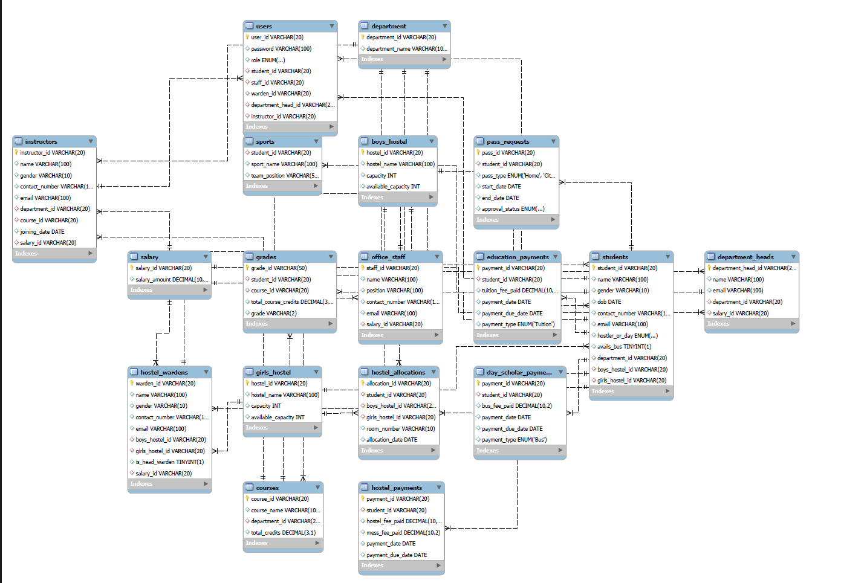

**SCHEMA DIAGRAM DESCRIPTION**

1. **Students Table**
   * Stores student details like student_id, name, gender, dob, and contact_number.
   * Links to department, boys_hostel, and girls_hostel.
   * Tracks hostel status (hostler_or_day_scholar).
   * Connected to grades, pass_requests, and payments.
2. **Users Table**
   * Manages login credentials with user_id, password, and role.
   * Role-based access for students, staff, wardens, and instructors.
   * Links to student_id, staff_id, instructor_id, etc.
   * Ensures security and controlled access to the system.
3. **Department Table**
   * Stores academic department details (department_id, department_name).
   * Connected to students, courses, and department_heads.
   * Helps categorize students and faculty under respective departments.
   * A department can have multiple instructors and courses.
4. **Department Heads Table**
   * Stores department head details like department_head_id, name, email.
   * Linked with salary details for financial tracking.
   * Manages department affairs and instructor supervision.
   * Connected to the department table.
5. **Courses Table**
   * Stores course details such as course_id, course_name, and total_credits.
   * Links to department and grades tables.
   * Defines academic subjects for students.
   * Instructors are assigned courses for teaching.
6. **Grades Table**
   * Tracks student performance with grade_id, student_id, course_id.
   * Stores grades and total credits earned.
   * Helps in academic evaluation and transcript generation.
   * Connected to students and courses.
7. **Instructors Table**
   * Stores instructor details (instructor_id, name, email, salary_id).
   * Connected to department and courses.
   * Manages faculty records and course assignments.
   * Linked to salary for payroll processing.
8. **Salary Table**
   * Stores salary details with salary_id and salary_amount.
   * Connected to instructors, department_heads, and office_staff.
   * Ensures payroll management for employees.
   * Tracks financial records for salary disbursement.
9. **Office Staff Table**
   * Stores staff details (staff_id, name, position, salary_id).
   * Manages non-teaching employees in administration.
   * Connected to salary for payroll tracking.
   * Ensures smooth functioning of college operations.
10. **Boys & Girls Hostel Tables**

* Store hostel details like hostel_id, hostel_name, capacity.
* Track available capacity for student accommodation.
* Linked to students for hostel allocation.
* Helps in hostel management and admissions.

1. **Hostel Wardens Table**

* Manages hostel warden details (warden_id, name, contact).
* Linked to boys_hostel and girls_hostel.
* Tracks warden responsibilities and hostel supervision.
* Connected to salary for payroll processing.

1. **Hostel Allocations Table**

* Tracks student room assignments in hostels.
* Links student_id with hostel_id and room_number.
* Stores allocation date for record-keeping.
* Ensures proper accommodation management.

1. **Hostel Payments Table**

* Tracks hostel fee payments with payment_id, student_id.
* Stores fee amount, payment date, and due date.
* Ensures proper financial record-keeping.
* Helps in hostel fee collection and auditing.

1. **Education Payments Table**

* Stores tuition fee payments for students.
* Tracks payment_id, student_id, tuition_fee_paid.
* Records payment date and due date for financial tracking.
* Ensures transparency in fee transactions.

1. **Day Scholar Payments Table**

* Manages payments for day scholars (bus fees).
* Stores student_id, bus_fee_paid, and payment details.
* Ensures financial tracking for non-hostel students.
* Helps manage transportation costs and revenue.

1. **Sports Table**

* Tracks student participation in sports activities.
* Stores student_id, sport_name, and team_position.
* Helps manage student extracurricular activities.
* Supports sports event planning and student engagement.

1. **Pass Requests Table**

* Manages student leave requests with pass_id, student_id.
* Stores pass type (leave, outpass) and approval status.
* Tracks request dates for proper record-keeping.
* Ensures controlled movement and student safety.

**Relationships Summary**

* **One-to-Many:** department → students, courses, instructors.
* **Many-to-One:** students → grades, pass_requests, hostel_allocations.
* **Many-to-Many:** students ↔ courses (through grades).
* **Hostel Management:** students → hostel_allocations, hostel_payments.
* **Financial Management:** students → education_payments, salary.

This structured schema efficiently manages student data, academics, hostels, payments, and faculty details.

**ENTITY RELATIONSHIP(ER) DIAGRAM**

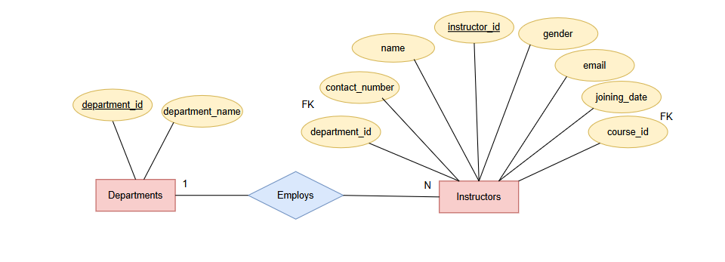

Each department assigns instructors to handle various courses and academic responsibilities under its domain. Instructors contribute to teaching and departmental activities. Technically, this is a one-to-many relationship where multiple instructors are linked to a single department using department_id as a foreign key in the Instructors table referencing the Department table.

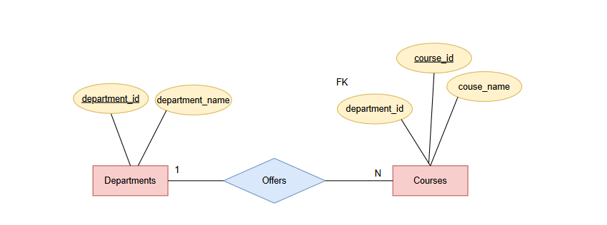

Each department offers multiple courses as part of its academic curriculum to cater to various subjects and specializations. The department is responsible for managing and updating these courses. Technically, this forms a one-to-many relationship where department_id in the Courses table acts as a foreign key referencing the Department table.

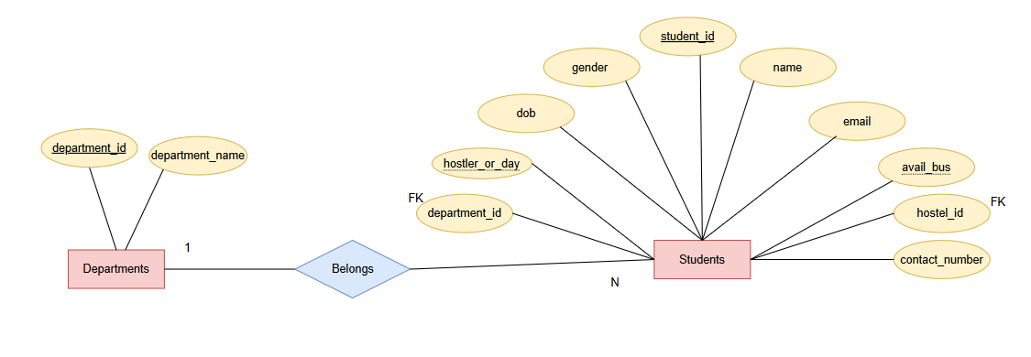

Each department enrolls multiple students who pursue courses and participate in departmental activities. The department manages the academic progress and records of its students. Technically, this is a one-to-many relationship where department_id in the Students table acts as a foreign key referencing the Department table.

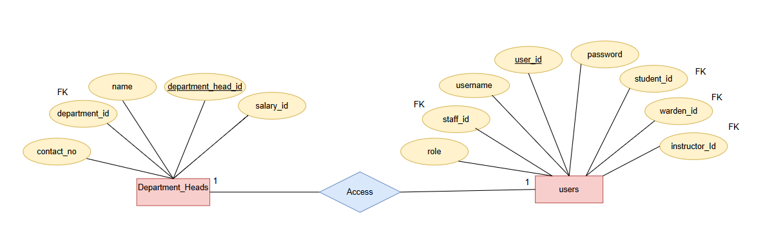

Each department head is assigned a user account to securely access the system and perform their administrative duties. This ensures role-based access control for department heads. Technically, this is a one-to-one relationship where department_head_id in the Users table acts as a foreign key referencing the Department_Heads table.

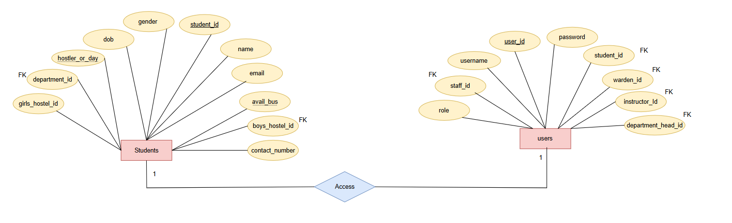

Each student is assigned a user account to access the system, view academic records, and manage personal details. This ensures secure and role-based access for students. Technically, this is a one-to-one relationship where student_id in the Users table acts as a foreign key referencing the Students table.

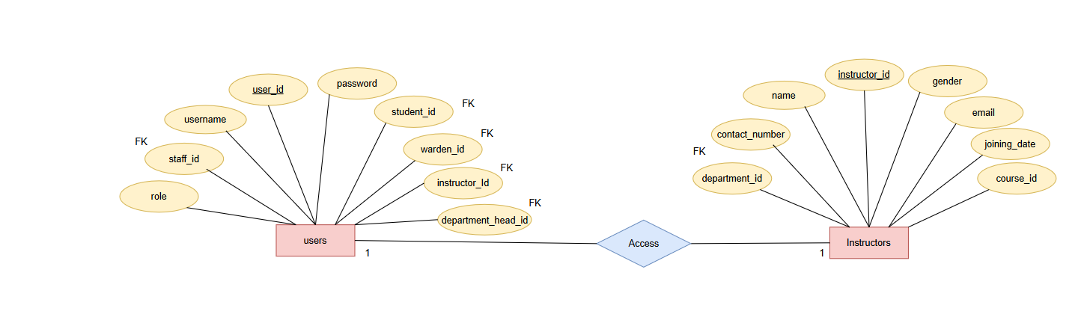

Each instructor is assigned a user account to access the system, manage courses, and update student records. This ensures secure and role-based access for instructors. Technically, this is a one-to-one relationship where instructor_id in the Users table acts as a foreign key referencing the Instructors table.

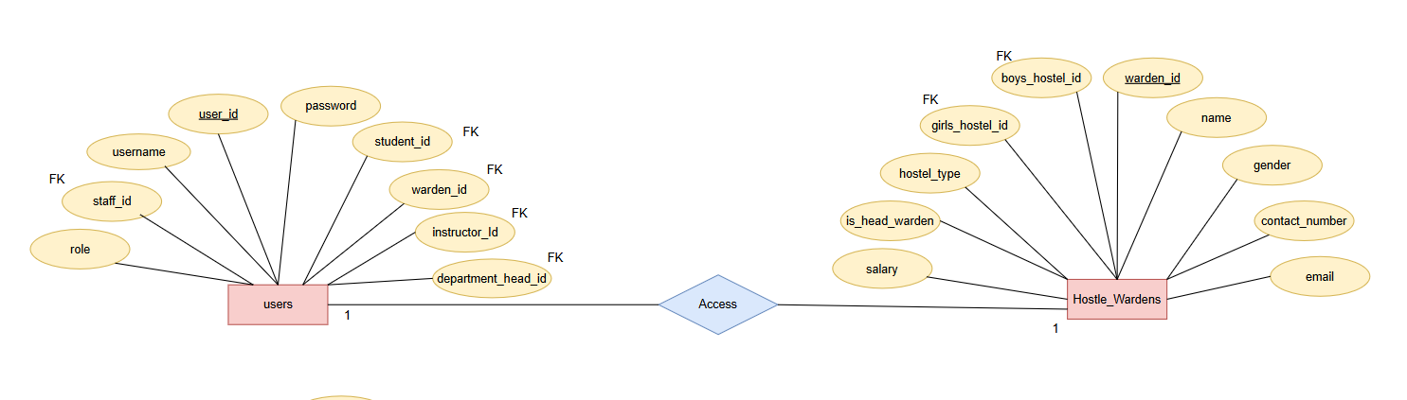

Each hostel warden is assigned a user account to manage hostel activities, student accommodations, and administrative tasks. This ensures secure and role-based access for wardens. Technically, this is a one-to-one relationship where warden_id in the Users table acts as a foreign key referencing the Hostel_Wardens table.

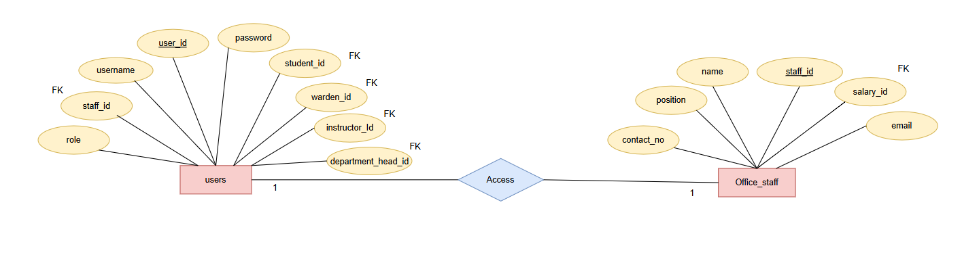

Each office staff member is assigned a user account to manage administrative tasks, student records, and payments. This ensures secure and role-based access for office staff. Technically, this is a one-to-one relationship where staff_id in the Users table acts as a foreign key referencing the Office_Staff table.

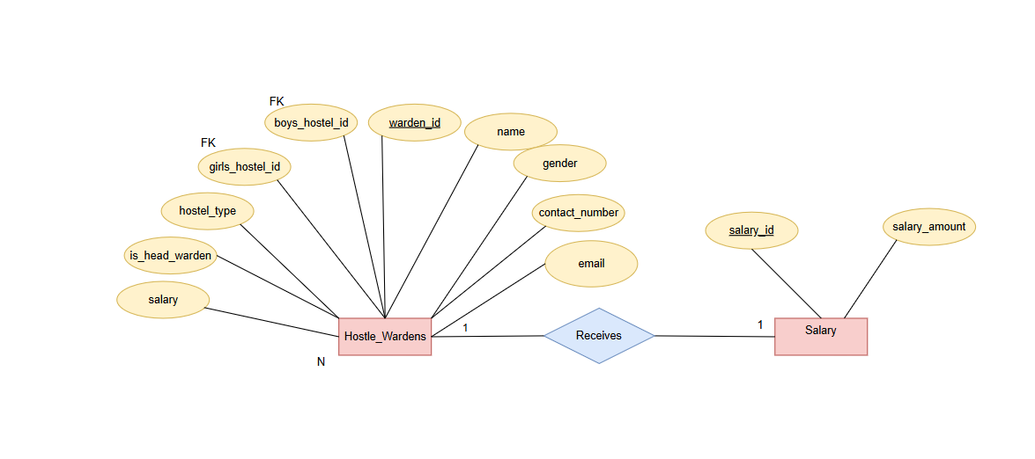

Each hostel warden is associated with a salary record that defines their compensation details. This ensures proper salary management and payment tracking. Technically, this is a one-to-one relationship where salary_id in the Hostel_Wardens table acts as a foreign key referencing the Salary table.

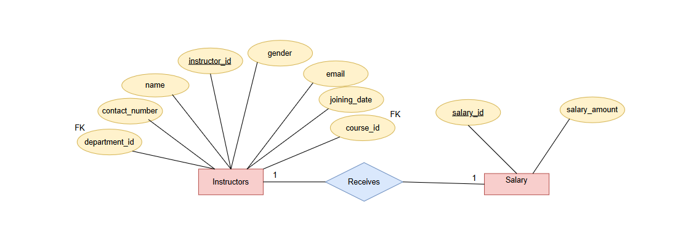

Each instructor is associated with a salary record that defines their compensation details. This ensures proper salary management and payment tracking. Technically, this is a one-to-one relationship where salary_id in the Instructors table acts as a foreign key referencing the Salary table.

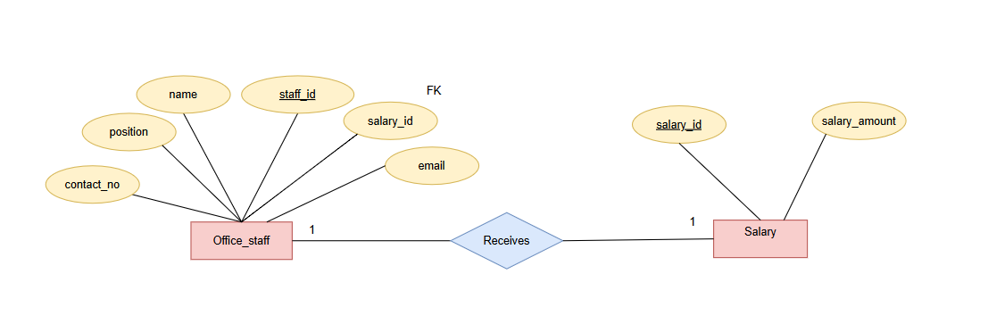

Each office staff member is associated with a salary record that defines their compensation details. This ensures proper salary management and payment tracking. Technically, this is a one-to-one relationship where salary_id in the Office_Staff table acts as a foreign key referencing the Salary table.

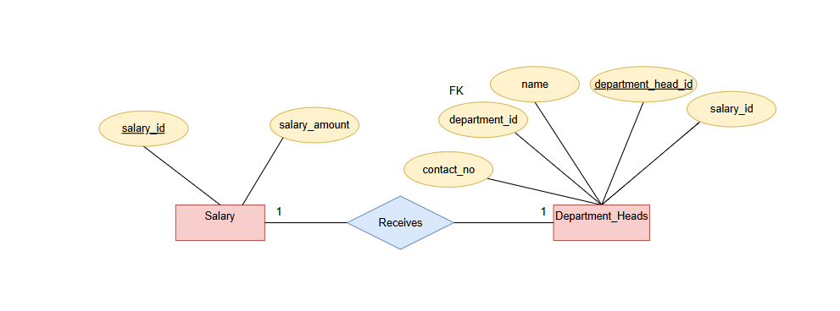

Each department head is associated with a salary record that defines their compensation details. This ensures proper salary management and payment tracking. Technically, this is a one-to-one relationship where salary_id in the Department_Heads table acts as a foreign key referencing the Salary table.

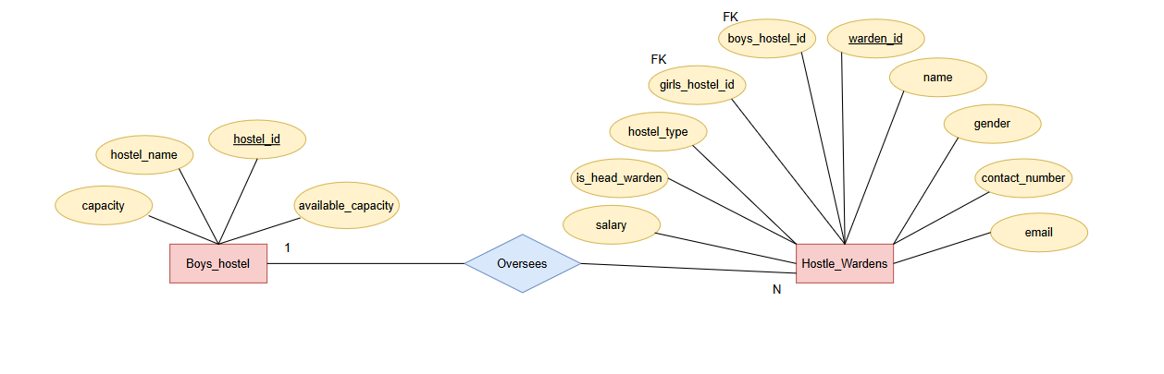

Each boys' hostel is managed by a hostel warden responsible for overseeing student accommodations and administrative tasks. This ensures proper hostel management and supervision. Technically, this is a one-to-many relationship where boys_hostel_id in the Hostel_Wardens table acts as a foreign key referencing the Boys_Hostel table.

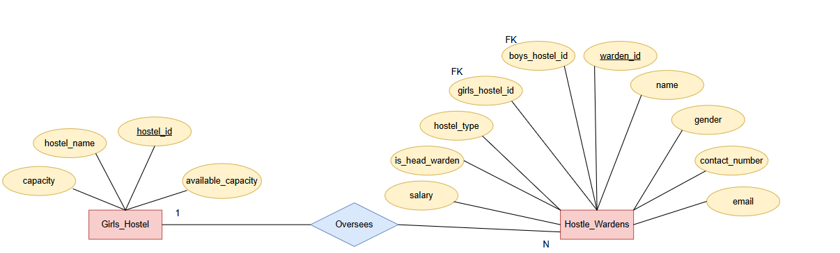

Each girls' hostel is managed by a hostel warden responsible for overseeing student accommodations and administrative tasks. This ensures proper hostel management and supervision. Technically, this is a one-to-many relationship where girls_hostel_id in the Hostel_Wardens table acts as a foreign key referencing the Girls_Hostel table.

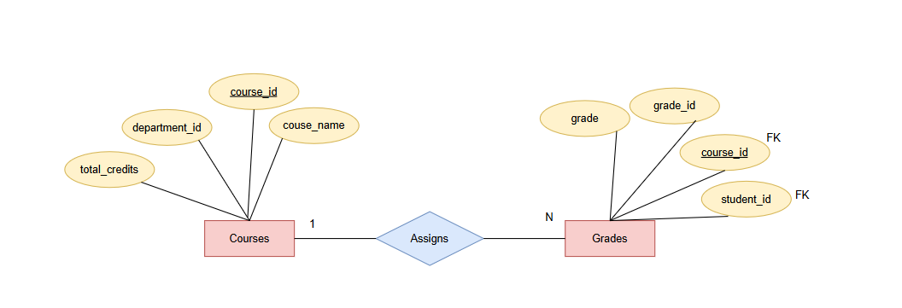

Each course is associated with multiple student grades, which record academic performance and credit details. This ensures proper evaluation and tracking of student progress. Technically, this is a one-to-many relationship where course_id in the Grades table acts as a foreign key referencing the Courses table.

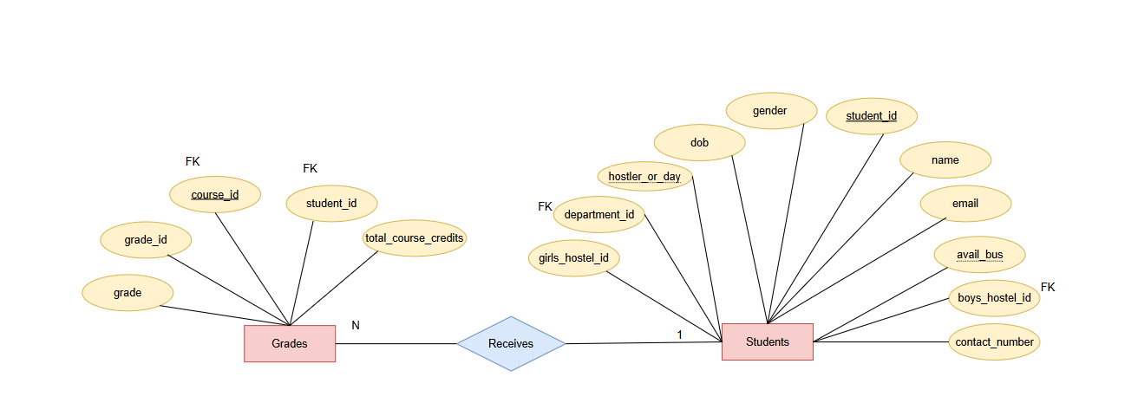

Each student is associated with multiple grades, which record their performance in various courses. This ensures proper evaluation and academic tracking. Technically, this is a one-to-many relationship where student_id in the Grades table acts as a foreign key referencing the Students table.

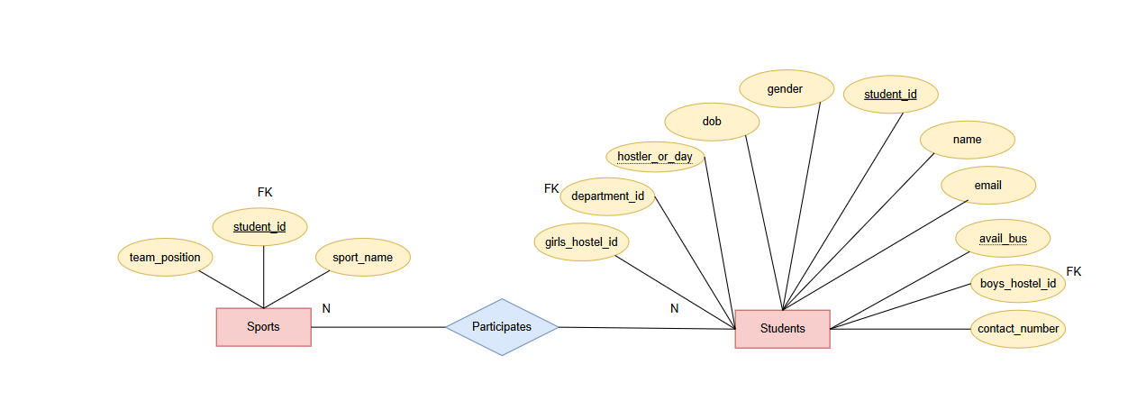

Each student enrolls in multiple courses as part of their academic curriculum, ensuring structured learning and progress tracking. Technically, this is a many-to-many relationship managed through the Grades table, where student_id and course_id act as foreign keys referencing the Students and Courses tables, respectively.

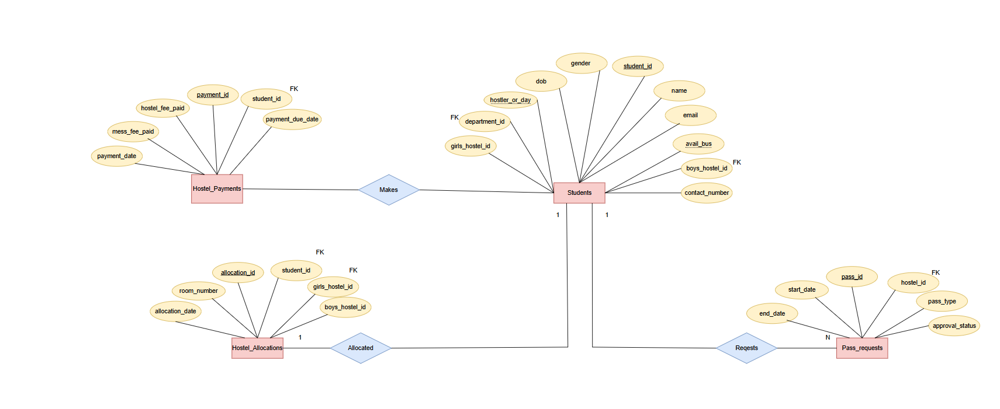

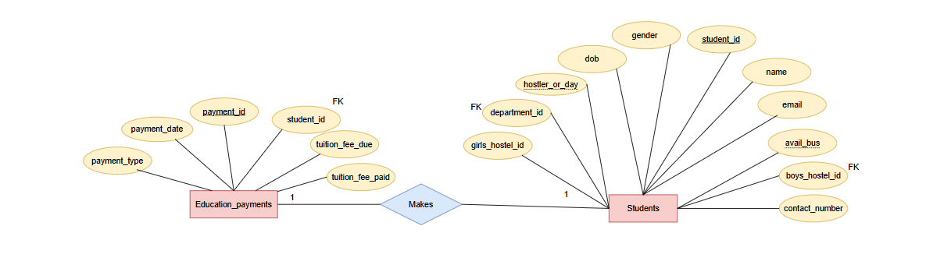

Each student makes multiple education payments for tuition and other academic fees, ensuring proper financial tracking and record-keeping. Technically, this is a one-to-many relationship where student_id in the Education_Payments table acts as a foreign key referencing the Students table.

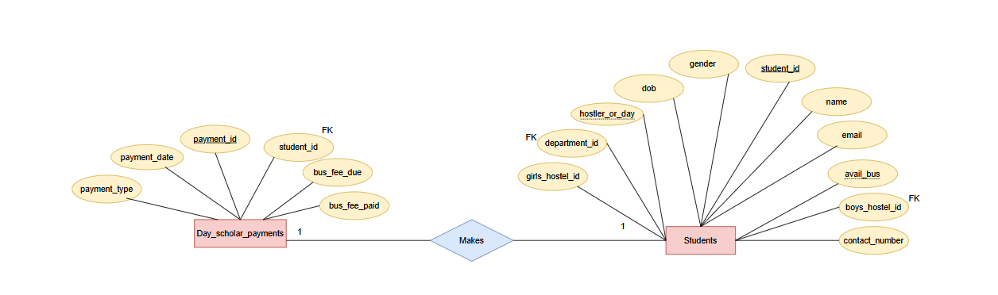

Each day scholar student makes multiple payments for transportation and related fees, ensuring proper financial tracking and record-keeping. Technically, this is a one-to-many relationship where student_id in the Day_Scholar_Payments table acts as a foreign key referencing the Students table.

**METHODOLOGY**

The development of the **Student Data Management System** followed a structured approach, ensuring efficiency, data integrity, and security. The methodology adopted for this project includes the following key phases:

1. **Requirement Analysis**
   * Identified the essential functionalities needed for managing student records, including student enrollment, course management, hostel allocation, and fee payments.
   * Defined user roles such as **students, instructors, administrators, and hostel wardens**, each with specific access permissions.
2. **Database Design**
   * Designed an **ER (Entity-Relationship) model** to map the relationships between key entities such as **students, instructors, departments, courses, hostels, payments, and grades**.
   * Created **normalized tables** in MySQL to eliminate redundancy and ensure data integrity using **primary and foreign key constraints**.
3. **Implementation**
   * **Backend Development**:
   * **Frontend Development**:
   * **Database Integration**:
4. **Security Measures**
   * Implemented **role-based authentication**, ensuring that only authorized users can access specific data.
   * Applied **input validation** and **data encryption techniques** to protect sensitive information such as passwords and financial records.
5. **Testing and Debugging**
   * Conducted **unit testing** to validate the functionality of each module, including student registration, course enrollment, and fee payment processing.
   * Performed **integration testing** to ensure seamless interaction between the **frontend, backend, and database**.
   * Fixed any **bugs and inconsistencies** found during testing to enhance system reliability.
6. **Deployment and Future Enhancements**
   * Deployed the system for internal use, ensuring smooth operation in managing student records.
   * Proposed future enhancements such as **web-based access, automated notifications, and cloud-based data storage** for scalability and improved user experience.

By following this structured methodology, the **Student Data Management System** ensures efficient **data handling, security, and automation**, reducing manual workload and enhancing institutional operations.

**USER INTERFACE:**

* **UI DESIGN FLOWCHART**

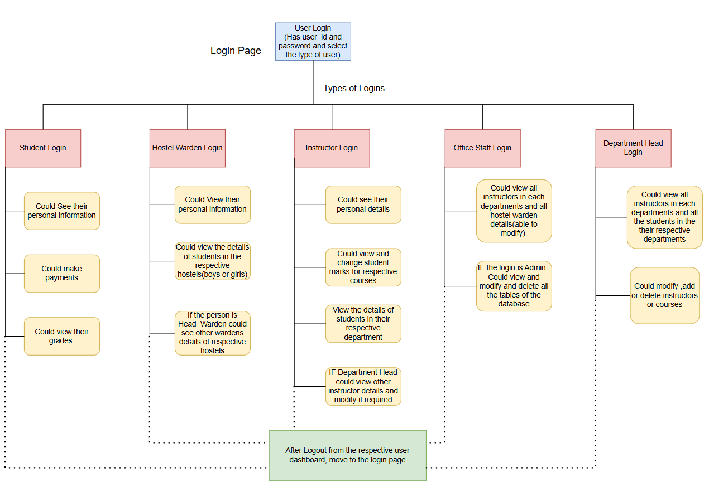

* **LOGIN DASHBOARD PAGE**

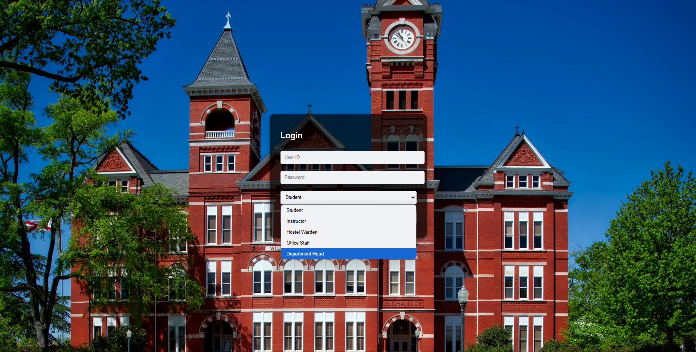

* **STUDENT DASHBOARD**

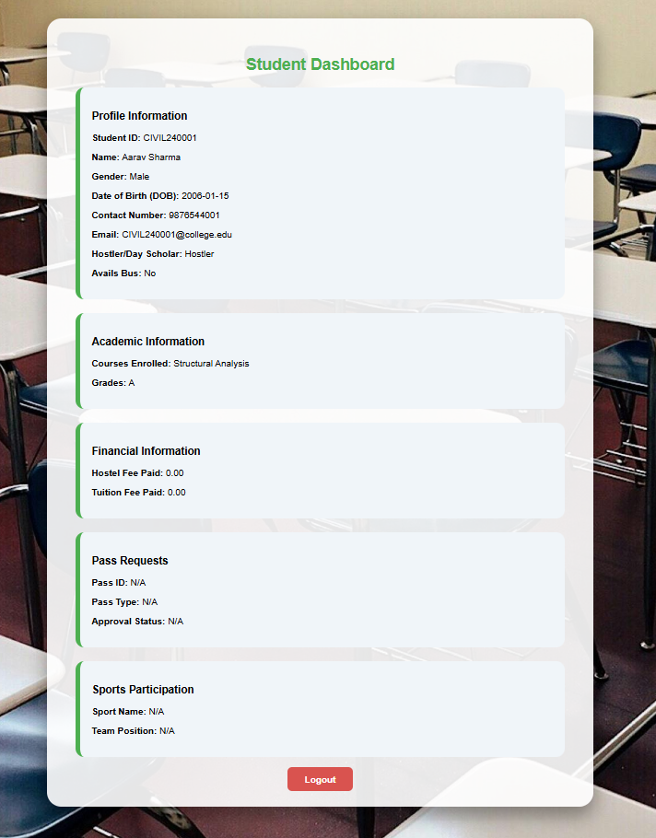

* **INSTRUCTOR DASHBOARD**

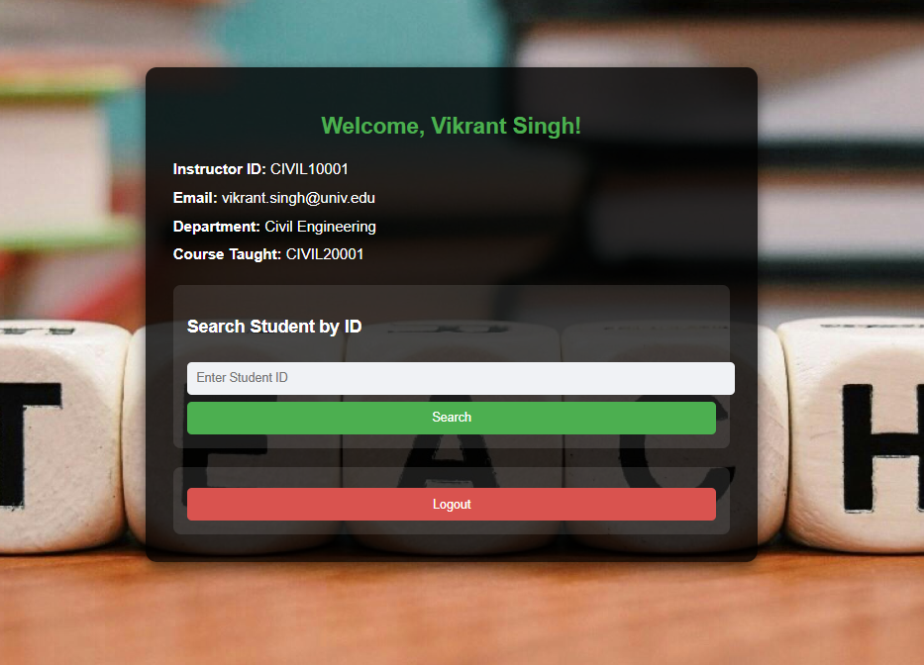

* **INSTRUCTOR DASHBOARD WITH STUDENT DETAILS**

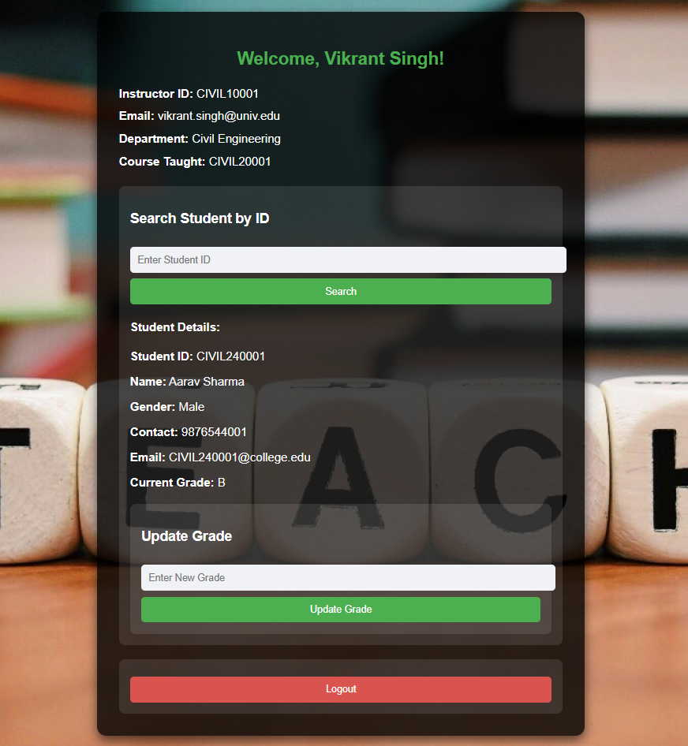

* **DEPARTMENT HEAD DASHBOARD**

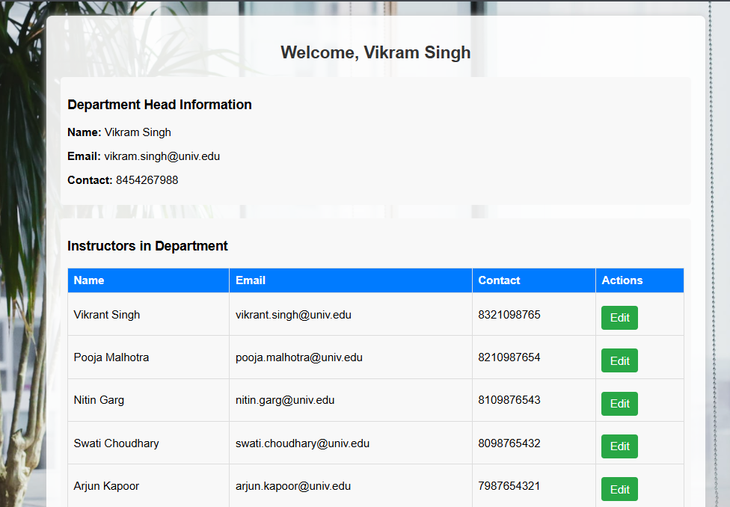

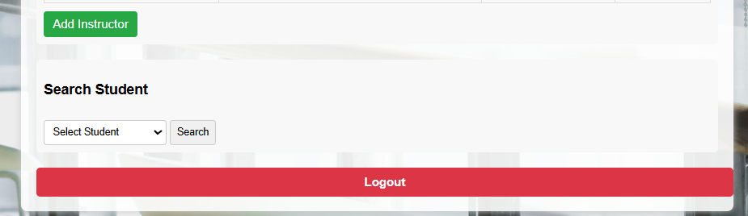

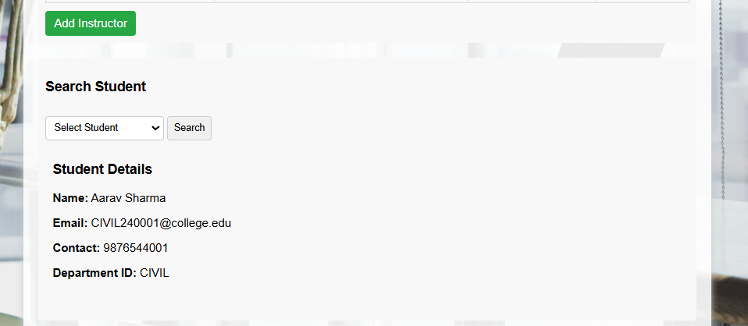

* **HOSTEL WARDEN DASHBOARD**

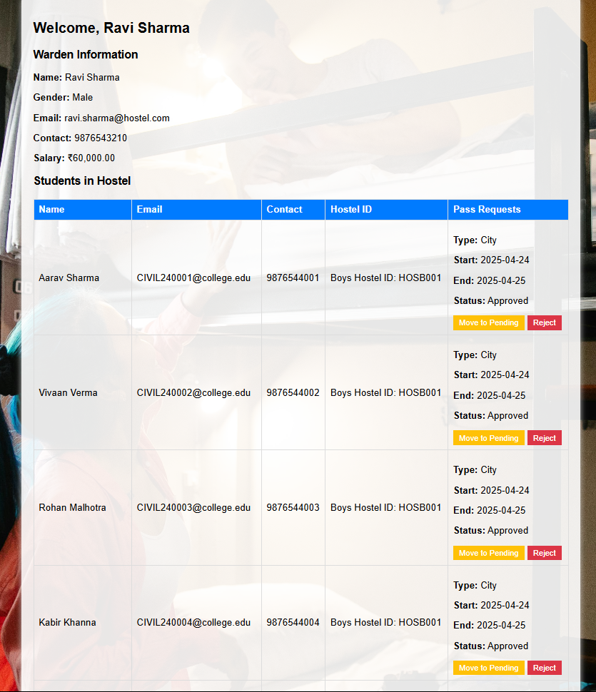

* **ADMIN DASHBOARD**

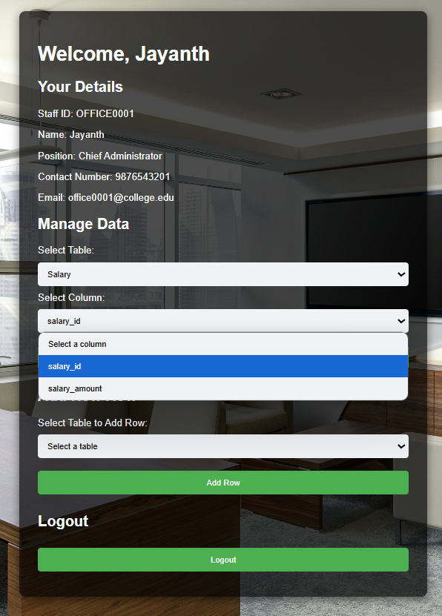

* **ADMIN UPDATING SALARY OF STAFFS**

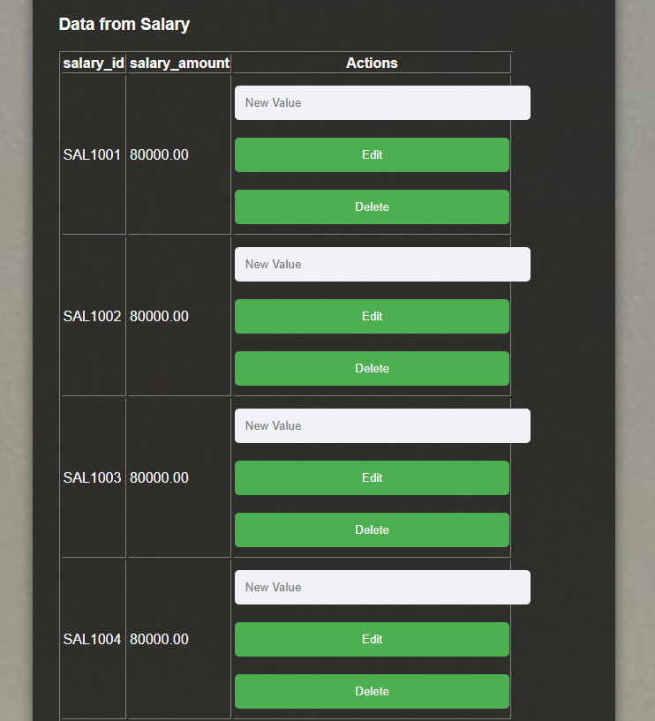

* **ADMIN ADDING NEW DATA INTO SPORTS TABLE**

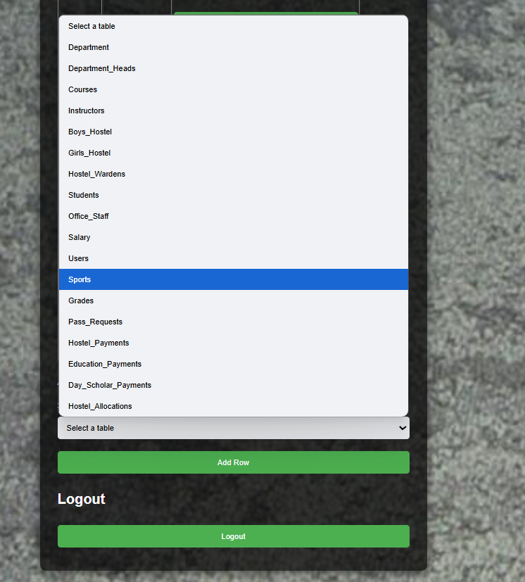

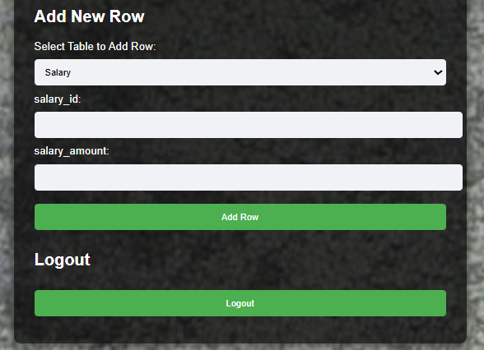 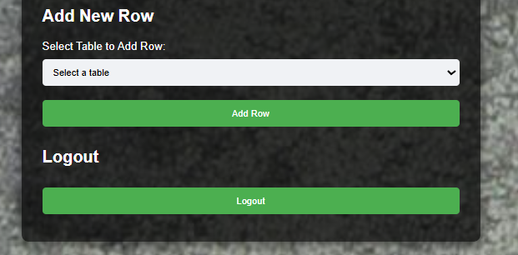

**FUNCTIONALITIES**

The **Student Data Management System** provides various features to streamline student records, academic activities, and administrative tasks. Below are the core functionalities of the system:

1. **User Authentication and Role-Based Access Control**
   * Secure login system with different user roles: **Administrator, Students, Instructors, Hostel Wardens, Office Staff, and Department Heads**.
   * Each role has specific permissions to access and manage relevant data.
2. **Student Management**
   * Student registration with personal details, contact information, and department allocation.
   * Updating and maintaining student records, including hostel or day scholar status.
3. **Course and Instructor Management**
   * Adding, updating, and deleting courses under different departments.
   * Assigning **instructors to courses**, tracking their details, and managing course credit information.
4. **Hostel Management**
   * Hostel allocation for students, maintaining **boys’ and girls’ hostel records**.
   * Managing hostel wardens and their assigned hostels.
   * Tracking **room allocations and available capacity** for efficient hostel space management.
5. **Fee and Payment Management**
   * **Hostel Payments**: Students can pay hostel fees, including mess charges.
   * **Education Payments**: Tuition fee payments and tracking pending dues.
   * **Day Scholar Payments**: Managing bus fee payments for day scholars.
6. **Pass Request System**
   * Students can apply for a **home or city pass**, specifying start and end dates.
   * Wardens can **approve or reject** requests based on predefined conditions.
7. **Grades and Academic Performance Tracking**
   * Instructors can assign grades to students based on their performance in courses.
   * Students can view their grades and total course credits.
8. **Sports Participation Tracking**
   * Managing student participation in sports activities, including **team positions and achievements**.
9. **Salary Management for Staff**
   * Managing salary records for **instructors, hostel wardens, department heads, and office staff**.
10. **Database Security and Maintenance**

* Enforcing **data integrity constraints** using primary and foreign keys.
* Implementing **data encryption** to protect sensitive student and financial records.
* Enabling **data backup mechanisms** to prevent data loss.

This system enhances **efficiency, automation, and security** in managing student data, reducing the manual workload for administrators and ensuring seamless academic and administrative operations.

**CONCLUSION**

The Student Data Management System successfully streamlines the management of student records, academic activities, and administrative operations within an educational institution. By integrating MySQL as the database, tkinter for the GUI, and Python for backend processing, the system ensures efficient data handling, secure authentication, and seamless role-based access control. Key functionalities such as student enrolment, course management, hostel allocation, fee payments, grade tracking, and pass requests enhance institutional efficiency while reducing manual workload. The implementation of data integrity constraints, encryption, and backup mechanisms ensures security and reliability. Overall, this project provides a structured, automated, and user-friendly solution to manage student-related data effectively, improving administrative processes and academic record-keeping.